

__________________________________________________________

**RHODES UNIVERSITY SUSTAINABLE LAND MANAGEMENT FOR RURAL RESILIENCE PROJECT (RU-SLMRR), GEF5**

**QUARTERLY PROGRESS REPORT**

______________________________________________________________

**Report compiled by**: Dugal Harris

**Organization**:

**Quarter and year**: 042017

**Reporting outputs**: 3.1b

**Date of report:** 11122017

__________________________________________________________________________________

# INSTRUCTIONS

# Please refer to Sections A-E below and include the necessary information and attachments to document your progress toward one or more outputs of the GEF5 SLMRR Project (use the examples provided to guide you).

# Please submit your completed progress report on or before the 12th day of the final month of a particular quarter. This is according to reporting regulations set by Department of Environmental Affairs for the GEF5 SLM Project.

# Please submit your report to: Rebecca Powell (rebeccajoub@gmail.com) and cc James Gambiza (j.gambiza@ru.ac.za).

# SECTION A: OUTPUTS PROGRESS & CHALLENGES (Please complete columns A-F in the table below)

**\***Progress toward achieving planned activities indicated in column C.

**\*\*** Challenges to achieving progress on activities, as identified in columns C and D

| AOutput code | BYR1 goals (deliverables) | CPlanned activities for reporting quarter | DProgress*1 = completed, no concerns; 0.5 = partial progress, some concerns; 0 = no progress, major concerns | EChallenges** | FAddressing challenges |
| --- | --- | --- | --- | --- | --- |
| 3.1b | Report on the development of a new carbon methodology for Spekboomveld rehabilitation projects and applicability to these kinds of projects | 1) Acquire, rectify and calibrate NGI aerial imagery of study areas.2) Generate custom high resolution, high accuracy DEM of study areas for accurate orthorectificaction.3) Literature survey of stereo aerial imagery for vegetation height derivation.4) Establish regression accuracy using 2005 CS GT and new orthorectified Quickbird image.5) Analyse field trial allometric data for informing modifications to sampling methodology.6) Assist in design of field carbon sampling methodology.7) Generate study area stratification maps and sampling plot locations. | 1) 12) 13) 14) 0.55) 16) 17) 0.5 | 1) NGI NIR band georeferencing and availability problems.2) DEM anomalies in homogenous areas like dams and fields.4) Accurate location information for 2005 CS GT plots is not available. This limits the usefulness of this data for remote sensing as it likely contributes to poor regression accuracies.5) Not all species have allometric models.7) Travel time between plots can be improved. Boundaries for Tchnuganu farm were incorrect. | 1) Separate NIR band images were obtained from NGI. These NIR bands were then stacked with the existing RGB images (after correcting georeferencing) and orthorectified using aero-triangulation data from NGI.2) It was established that the GEF sampling areas exist outside of problem DEM zones.4) It is unlikely that further work on 2005 CS GT will prove to be useful. A new regression analysis should be conducted on accurately located GEF sampling data with Worldview imagery in 2018.5) Species without models were grouped into guilds with known species.7) Sampling plot locations should be updated with correct farm boundaries. Plot clustering should be investigated as an option to decrease travel time. |

# SECTION B: IDENTIFIED RISKS AND SOLUTIONS

# Describe the identified risks to the project outputs

# *There are currently no risks to completing the carbon stock mapping study in 2018. The limited success of the initial feasibility study does however have an impact on the work that will be conducted in 2018:*

# *The lack of precise corner co-ordinates for the 2005 carbon stock ground truth (2005 CS GT) plots means that there is uncertainty in the location of these plots in the Quickbird satellite image. This uncertainty has a negative impact on the carbon stock mapping accuracy that can be achieved with this data.*

# Describe possible solutions to identified risks

# *New carbon stock ground truth is in the process of being gathered for the GEF study area. The precise corner locations of these sampling plots is being logged with a DGPS. Work in 2018 will focus on mapping carbon stocks using this data and a Worldview-3 satellite image. The Worldview-3 image represents an improvement in terms of both spatial and spectral resolution compared to the Quickbird image used in 2017.*

# SECTION C: SUMMARY OF LESSONS LEARNT DURING THE REPORTING QUARTER

# *A high (geolocation) accuracy, high resolution DEM can be generated using freely available aerial imagery from NGI.*

# *The geolocation accuracy of suitable satellite imagery orthorectified with such a DEM is sufficient to accurately locate GEF sampling plots.*

# *A nested plot design (where measurement of plants below a height threshold is restricted to a small subplot) can be adopted without significantly affecting the accuracy of carbon stock estimates.*

# SECTION D: BUDGET TRACKING

# Please note that you will be required to submit a financial report at the end of 2017 (Before December) detailing your expenditure for the year. This requires that you keep a record of all invoices and receipts relating to project expenditure. The format for the report will be sent closer to the time.

**SECTION E: APPENDICES**

**APPENDIX 1:**

*A high resolution DEM was generated using freely available 0.5m aerial imagery from NGI. This NGI DEM provided a significant improvement in accuracy compared to the previously used SUDEM L2a and SRTM DEM’s. DEM accuracies were established by comparing heights to those of GCP’s (ground control points) gathered with a DGPS in the field.* Figure *1 shows a comparison of the NGI and SRTM DEM accuracies.*

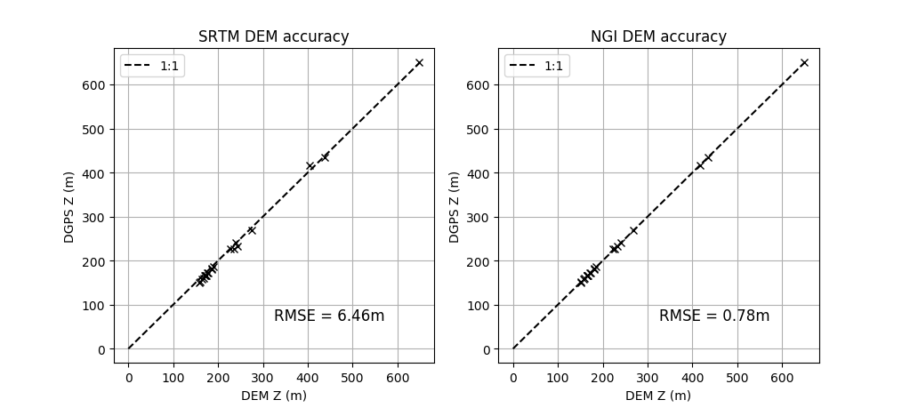

Figure 1 NGI DEM Accuracy Comparison

**APPENDIX 2:**

*An initial investigation into the possible usefulness of using the NGI DEM to provide a crude measure of vegetation height was conducted,*

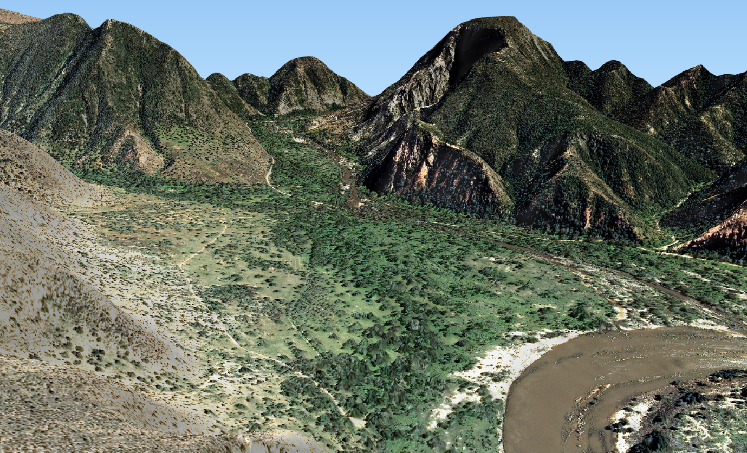

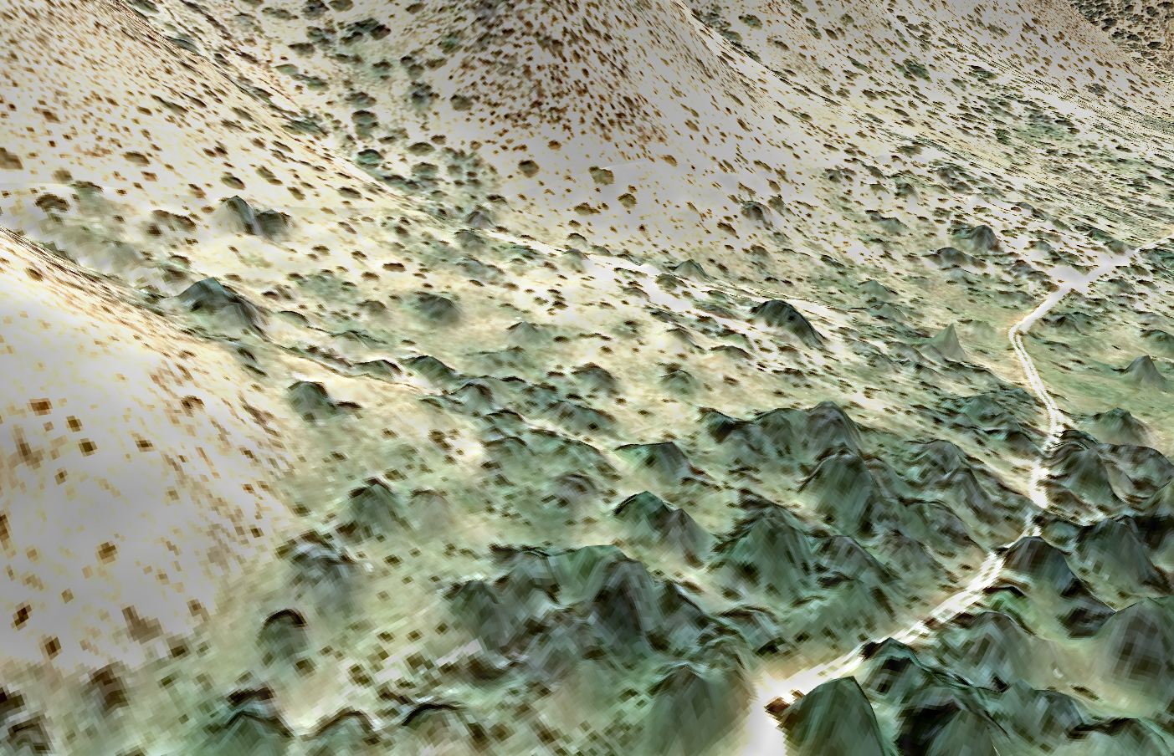

**APPENDIX 3:**

*Four band (red, green, blue and near-infrared) imagery.* Figure 2 *shows a colour-infrared rendering of the orthorectified NGI aerial imagery covering the GEF study areas. Degradation strata and sampled plots are displayed on the map.*

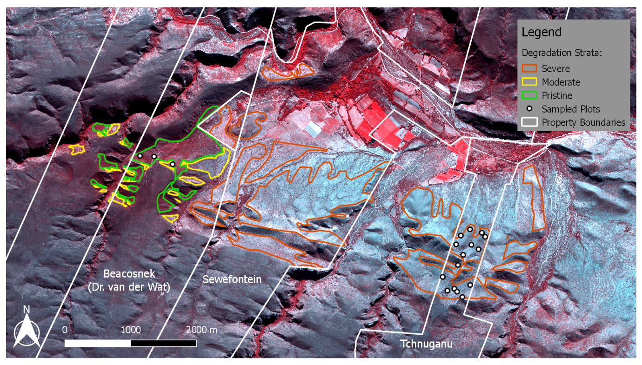Figure 2 Map of GEF Study Areas

**APPENDIX 4**

*The effect of increased plot size on the strength of correlation between derived image measurements and carbon stock ground truth was simulated using the 2005 CS GT. Larger plot sizes were simulated by combining data for multiple plots into one pseudo-plot. Plots were only combined with other plots belonging to the same degradation class. The degradation classes were OL = “old lands”, DST = “degraded subtropical thicket” and ST = “intact subtropical thicket”. The original plot sizes were 5x5m for DST and ST, and 25x25m for OL. R2 values were found for the relation between log(TAGC) and NDVI for the combined plots. Results are shown in* Figure 3*. These results are relevant for the selection of plot size for the GEF carbon stock inventory and imply that there are significant improvements to be gained from using larger plot sizes. The simulation is crude however and the R2 values should not be taken as indicative of what will be achieved in the GEF5 study area.*

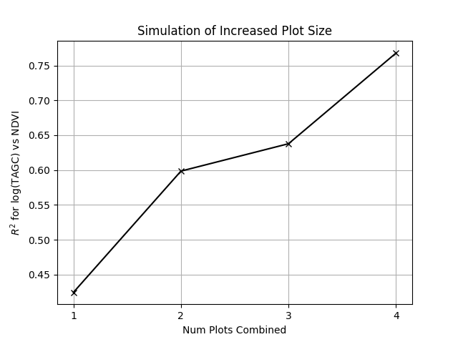

Figure 3 Simulation of Increased Plot Size

**APPENDIX 4**

*It was found that orthorecitifacation using the 5m SUDEM (Stellenbosch University DEM) was resulting in poor geolocation accuracy. The accuracy of SUDEM was analysed by comparing heights to the DGPS acquired heights at the GCP points. A similar comparison was made with the 30m SRTM DEM. The SRTM DEM was found to improve on the accuracy of SUDEM. Results are shown in* Figure *4.*

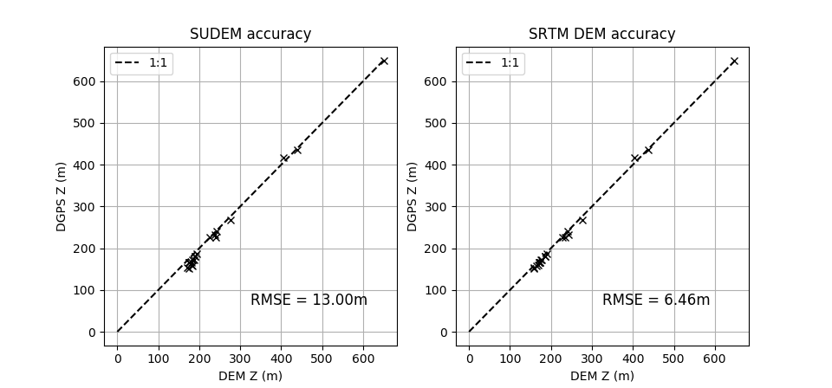

Figure 4 DEM accuracy analysis